|  |  |
| --- | --- |
| **Meeting Recap** | **May 15, 2024** |

**Welcome and Introductions**

The BOD Chair, RJ Gillespie started the meeting. The meeting was held as a hybrid (in-person/virtual) meeting where all participants could hear and participate. Once the meeting had started Candice Jimenez and Hillary Fleming then did a ceremony blessing of the meeting. After the blessing was performed Luci Longoria started the group on a round-robin of introductions.

**Topic 1: Contract Approvals**

The Board discussed the following contracts:

* **Basic Health Program (BHP) Bridge Contract:** Rod Cook moved to approve the above contract, and Eric Hunter seconded the motion. The Board unanimously approved the above contract.
* **Share Services Agreement; Traditional Health Workers (THWs) support**: Bob Stewart moved to approve the above contract, and Kyle King seconded the motion. The Board unanimously approved the above contract. Rod Cook and Mjere Simantel abstained.

**Topic 2: Bylaws Amendment**

* Amendment to Bylaws to expand permissible scope of Health Share’s service population to include Basic Health Plan beneficiaries. Jeff Conklin moved to approve the proposed amendment to the Bylaws. Rod Cook seconded the motion. The Board unanimously approved the amendment.

**Topic 3: Blanket Ceremony**

To honor Camille Applin-Jones as she departs the Health Share board of directors a blanket ceremony was presented by Heather Reppeto and Aaron Morgan. This ceremony honored Camille as she was presented a blanket and then each member wished her well.

**Topic 4: Highlights of CAC Contributions in 2023**

Phyusin Myint presented highlights from calendar year 2023 of the contributions made by the Community Advisory Committee (CAC). She shared the objective which are to deepen relationships, refine CAC’s role within Health Share’s Governance and develop a CAC power-building strategy to strengthen Health Share’s health equity goals.

Myint shared the 2023 CAC programmatic highlights:

* FIOC (SHARE food proposal support).
* feedback on redetermination.
* SHARE highlights (supporting policy development and RFP process).
* CHIP/CHNA priorities.
* social needs screening metrics.

During this time CAC members were encouraged to share their experiences from when they participated in the different areas discussed. Phyusin also shared the process for the CAC to bring proposals and track outcomes to the Board through the CAC’s logic model. Next, she shared the emerging recommendations from the CAC to the Board which are to:

* create a consistent practice of adding a racial equity lens frame to all new propose policies.
* invite community-based organizations to build relationships with the CAC.
* carry out an audit of Health Share’s community engagement practices as the CAC wants to review that there is appropriate staff and resource allocation to promote authentic community engagement practices.
* make space for restoration and self-care into CAC praxis.

There was conversation regarding these recommendations from the group.

**Topic 5: 2024 SHARE Spending Plan Approach**

Christine Bernsten and Maria Tafolla presented the SHARE spending approach for the current year.

Christine presented an overview of the SHARE initiative and the primary goals of the same. She then presented the process for SHARE review in 2022 and 2023.

The SHARE Initiative comes from a legislative requirement for coordinated care organizations (CCOs) to invest some of their profits back into their communities. After meeting minimum financial standards, CCOs must spend a portion of their net income or reserves on services to address health inequities and the social determinants of health and equity (SDOH-E).

The primary goals of the SHARE Initiative are to

Safeguard public dollars by requiring that a portion of CCO’s profits are reinvested in their communities; and improve CCO member and community health by requiring reinvestments go toward upstream nonhealthcare factors that impact health (for example, housing, food, transportation, educational attainment or civic engagement).

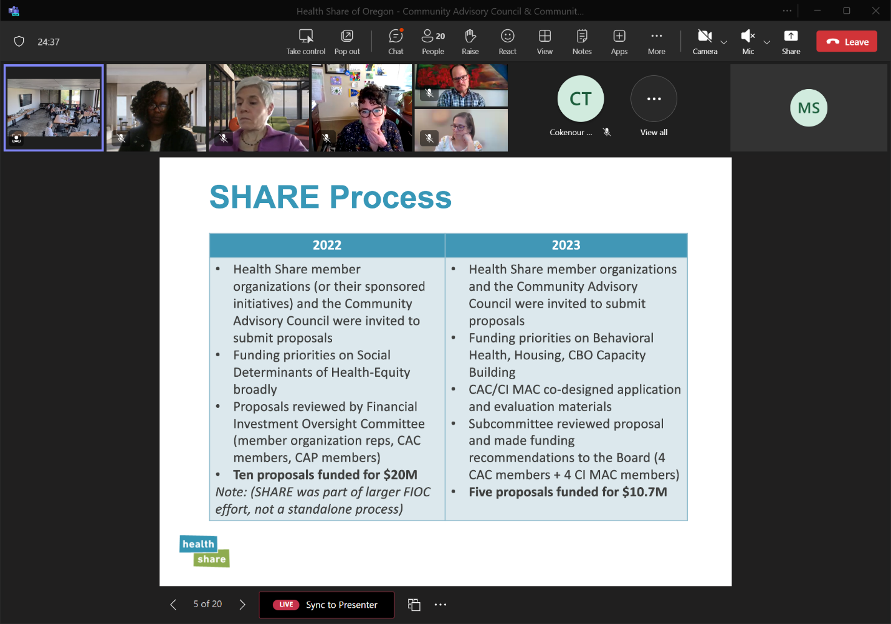

SHARE Process

Next, Maria presented on the 2024 SHARE process. She began by discussing the constraints faced by the process in 2024.

Constraints

* Less SHARE dollars are available to distribute.
* One-time funding.
* The capacity of Health Share staff to support several new investments.
  + 15 SHARE projects currently in process which consists of 22 contracts.
  + Community Capacity Building Funds – review applications, select organizations to fund, develop contracts, support implementation and it is unclear the number contracts will come for this.

Maria presented three potential proposed investment approaches for the 2024 SHARE process.

Strategy Investment Options

* Option 1: Review current investments and determine if any projects need additional funding support.
* Option 2: Identify new investments to support; only capital investments, alignment with ecosystem priorities.
* Option 3: Braid SHARE funding to support things that cannot be paid for with CCBF dollars.
* Other 4: Other

She presented the CAC’s recommended approach to the Board for the preferred 2024 Share process, including options for CAC and CIC input and Board engagement.

Recommendations from CAC, CI MAC & CIC

Emerging Recommendation:

* Preference for option 1 or 2, or combination of the two
* Combine all options presented: support current investments in the CBO capacity building category that are in service to developing the Health-Related Social Needs network (e.g., Center for Supportive Housing, Culturally Specific Food Access), with a priority on capital investments that cannot be paid for with CCBF dollars.

Community Advisory Council and Community Impact Committee Input:

* Preference for either option
* Topical areas to focus SHARE funding on
* Provide additional funding to current projects, to prioritize projects that with a little more investment, would be able to be sustained.

Board Engagement:

* What are the current Board priorities?
* What recommendation best aligns with Board and Community priorities?

Maria and Christine responded to comments and questions from the Board and CAC members. The conversation was robust with many comments, questions, and feedback.

**Topic 6: Public Comment**

Luci Longoria opened the meeting to public comment. No public comments were made.

**Topic 7: Community Health Improvement Plan 2024**

Maria Tafolla presented regarding the CAC’s path to the Community Health Improvement plan and its current priorities.

CHNA & CHIP Journey

Our Path to the Community Health Improvement Plan (CHP)

Community Health Needs Assessment Data is collected.

Community Health Improvement Plan is implemented.

Community Health priorities are identified.

Community Health Improvement Plan is developed.

Input from community and key partners is gathered.

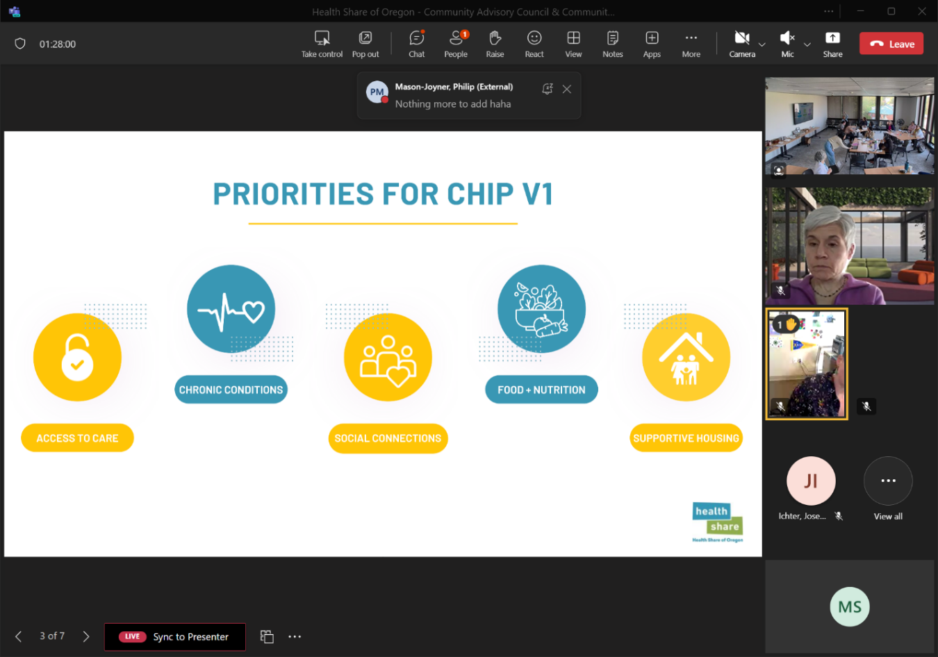

Maria then discussed its process for the development of its new priorities: access to care; prevention; and social health needs.

The Board was asked to vote on the proposal for the 2024 CHP priorities. Bettyna Rosales moved to approve the CAC’s proposal for 2024 Community Health Improvement Plan priorities. Marrin Permit seconded. The Board unanimously approved the motion.

Luci Longoria led a group activity and discussion regarding these questions:

* What priorities within these areas are of strategic importance to you?
* What considerations would you offer us in thinking about how best to integrate this work into upcoming strategic plan work?

There were four groups that were comprised of CAC and Board members to discuss these questions. At the end of the time each group presented the information from their discussion. The following are some of the notes from discussions:

Group 1:

Prevention: making policies environmental beyond education (only)

Group 2:

Prevention:

* prioritizing strategies
* Challenging to measure / data pieces
* THWs in all areas
  + challenges in workforce support
  + Need to legitimize profession

Group 3:

Prevention & Access to Care

* If we address this it also aligns with the other 2 priorities
* Cultural perspective (i.e. language)
* Some communities don’t know what prevention means

Group 4:

Social Health Needs

* Social-emotional
* Social cohesion

Access to Care

* Many less resources for children than adults
* Reality is schools and primary care providers can’t meet the need either, needs to many and resources to few.
* Peer support

Have we condensed/expanded our priorities to now encompass everything and do we have the capacity necessary to be effective.

**Wrap-up**

There were no further comments or questions presented. Meeting adjourned.

**Meeting Schedule:**

Next meeting is scheduled for **June 12**, from **1:30pm – 3:30pm**.

|  |  |  |
| --- | --- | --- |
| **Participation - CAC** | | |
| **Organization** | **Representative**  **(Indicate Proxy if present)** | **Present** |
| Oregon Health Authority | Rebecca Donnell |  |
| Clackamas County Council Representative | Jaime Zentner | x |
| Multnomah County Council Representative | Natasha Davy | x |
| Washington County Council Representative | Magdalena Ramirez | x |
| Community Council Members | Candice Jimenez | x |
| Siletz Tribal Representative | Forrest Pearson | x |
| Community Council Members | Lung Wah Lazum | x |
| Community Council Members | Triniece Rozier-Sheidun | x |
| Community Council Members | Yamungu Seraya | x |
| Consumer Council Members | Francisco Elias | x |
| Consumer Council Members | Hilary Flaming | x |
| Consumer Council Members | Joy Mutare | x |
| Consumer Council Members | Lauren Riddle | x |
| Consumer Council Members | Rachel Schutz | x |
| **Participation – Board of Directors** | | |
| **Organization** | **Representative**  **(Indicate Proxy if present)** | **Present** |
|  | Andy Mendenhall | x |
|  | Bettyna Rosales | x |
|  | Bob Stewart | x |
|  | Camille Applin-Jones | x |
|  | Candice Jimenez | x |
|  | Eric Hunter | x |
|  | Holden Leung | x |
|  | Jeff Conklin | x |
|  | Joe Hardman | x |
|  | Kyle King | x |
|  | Merrin Permut | x |
|  | Mjere Simantel | x |
|  | RJ Gillespiex | x |
|  | Rod Cook | x |
|  | Christa Shively |  |
|  | Keith Dempsey |  |
|  | Monta Knudson |  |
|  | Rachael Banks |  |
|  | Katrina Holland |  |
| **Participation – Health Share Staff** | | |
| **Organization** | **Representative**  **(Indicate Proxy if present)** | **Present** |
| Health Share of Oregon | Anthony Montoya | x |
| Health Share of Oregon | Beth Spinning | x |
| Health Share of Oregon | Christine Kan | x |
| Health Share of Oregon | Graham Bouldin | x |
| Health Share of Oregon | Karla Tupper | x |
| Health Share of Oregon | Love Richardson | x |
| Health Share of Oregon | Luci Longoria | x |
| Health Share of Oregon | Maria Tafolla | x |
| Health Share of Oregon | Mariam Ukbazghi | x |
| Health Share of Oregon | Mariotta Gary-Smith | x |
| Health Share of Oregon | Marissa Sliwka *(recorder)* | x |
| Health Share of Oregon | Mark Lewis | x |
| Health Share of Oregon | Mindy Stadtlander | x |
| Health Share of Oregon | Phyusin Myint | x |