|  |  |
| --- | --- |
| **Meeting Recap** | **July 10, 2024** |

**Welcome and Introductions**

Luci Longoria welcomed the group and then started a round-robin of introductions. The group welcomed Abraham Rodriguez Guillen & Ophelia Vidal.

**Topic 1: Community Engagement operations**

Luci discussed community engagement operation updates:

* CAC meeting notes from
  + April, May 8th, May 15th, & June: please email Luci with approval or if you need more time to review. It would be helpful to receive responses by the end of the week.
* CAC meeting Cadence

August – virtual September – in-person

October – virtual November – in-person

December – virtual

It was discussed that having a hybrid schedule is a great way to continue to build the rapport the team is establishing at the same time easy back into an in-person schedule. We will have two joint CAC/Board meetings a year. For monthly meetings they will be hosted at the Health Share building; however, the joint CAC/Board meetings will be held in the community. If you have any other feedback, you are welcome to outreach to Luci Longoria.

* CAC-appointed Board Liaison update

Hilary Flaming was nominated to be the CAC – Board Liaison; and their nomination was reviewed by the Board on the 26th of June. They voted Hilary on as the Liaison. Hilary thanked the group for their support and the nomination. Hilary will be working with Candice, who is the other CAC-Board Liaison. Phyusin will be working to support the CAC-Board Liaisons just before the Board meetings to give them the support they need before going to the meeting. Candice shared her appreciation for the group.

* CAC membership and recruitment updates

Triniece has stepped down from her role on the CAC. Luci and Maria are reviewing the current demographic of our CAC as they connect with applicants that have turned in their applications. In a future meeting, the group will discuss next steps in our recruitment strategy. Maria has outreached to previous applicants to see if they are still interested in possible membership, and at this time, all applicants have reached indicated that they are still interested. There was a question about how many members are supposed to be on the council, it was stated that there are 17 seats on the council. However, only 12 seats are filled. As decisions and determinations are being processed, thought is also going into tribal representation. Luci stated that they would follow up with Hilary and Candace regarding possible candidates for Tribal representation. Christine Kan shared that there is a recruitment strategy and helpful information that can be shared with the group as we revisit this conversation

* CAC Stipend Process and updated form

Luci went over the updated stipend form as well as the process. Once a form is turned in, it needs to be signed and then turned into the vendor invoice group. For first-time forms being turned in, a W9 must be submitted so that CAC Members can be entered into the system as a vendor. This allows for Health Share to pay out the stipend. If you have any questions, please reply to Luci.

**Topic 2: SHARE Update; CCBF update & prep for August recommendation**

**Community Capacity Building Funding**

Ophelia presented the updated information on the Community Capacity Building (CCBF).

Funding Background and 2024 Goals

* Health Share had **10.77M** to award for 2024.
* This funding **must support the development of a provider network** for HRSN housing and food benefits.
* Health Share developed and publicly shared [funding priorities](https://www.healthshareoregon.org/storage/app/media/2024%20Community%20Capacity%20Building%20Funding%20Rubric.pdf) for 2024 and stated investments would be made in specific categories.
* Application closes Friday, May 31.
* Funding recommendations were due to OHA Monday, June 17.
  + Our teams and external teams worked extremely hard on this process. THANK YOU to all for their help getting through this process.

*Note: 2024 Allocation for Trillium: $1.39M; Yamhill $1.31M*

CCBF Application Statistics

* 99 applications received; totaled $51,370,843.
  + 64 organizations asked for funding to support Housing Benefits.
  + 60 organizations asked for funding to support Food benefits.
  + 10 organizations asked for funding to perform Network Hub functions.
* Recommendations approved by Health Share’s Board Executive Committee on June 13.
* Corporation for Supportive Housing (CSH) provided pre-application technical assistance.
  + 42 individuals from 29 organizations participated in the learning and group TA sessions.
  + CSH (Center for Supportive Housing) had 40 individual sessions with 23 organizations.

CCBF Funding Recommendations

* **38 applications** recommended for full or partially funded (38% of total applications received); awaiting OHA approval by end-of-day July 15th.
* 26 organizations will be new partners (no prior contracting relationship).
* 46% of the Housing organizations and 72% of the Nutrition organizations are culturally specific
* **Counties** will serve in **Hub/network manager roles**; still confirming final functions/staffing plan and associated budgets.
* Health Share has an **additional $4.3M** ($2.8M from 2023 SHARE, $1.5M from CSH contract) that we are proposing to be used to support:
  + Additional TA/provider readiness and small stipends for organizations not funded in this round.
  + Capital investments for nutrition providers (e.g., refrigerated trucks).
  + Co-creation of outreach materials by group of culturally specific providers.

CCBF Next Steps

OHA has until July 15 to approve our award recommendations:

* July 10: Recommendations reviewed with CAC.
* Week of July 15:
  + Award Notifications sent out to organizations recommended for funding.
  + Start of contract negotiations.
* July 24: Recommendations reviewed with Health Share’s Community Impact Committee.
* July 24: Recommendations reviewed, and Plan Partner contracts approved by Governance.
* August 1: Health Share receives the CCBF dollars.
* August 1-15: Contracts finalized.
* August 21: Health Share Board of Directors approves Partner (County, CCC (Central City Concern)) contracts.
* By end of August: public announcement of awardees.

Discussion

Phyusin took time to discuss the information that was presented. For the CCBF, there were three areas of emphasis: Housing, Nutrition and Hubs/Network Managers. This process has gone quickly to meet OHA deadlines, and a lot of work has been done in a short period of time to prioritize our values on engagement and community needs.

A question was asked if it was possible duplicate funding awards could happen as Trillium had money to fund organizations as well. Health Share and Trillium worked together so that duplicate funding didn’t happen and that more organizations could be funded.

There was a call out regarding the amount of money requested versus the amount that could be funded. This highlights the magnitude of need in the community.

A question was asked if all the counties applied? Yes, they did, and they are being recommended to partner with us as network hubs. The counties already have systems in place for Housing and can support this.

**2024 SHARE Spending Plan Update**

Phyusin Myint presented on the SHARE spending plan update as Maria Tafolla was not able to be present at the meeting.

2024 Timeline

Proposed Investment Approaches

* **Option 1:** Review current investments and determine if any projects need additional funding support.
* **Option 2:** Identify new investments to support; only capital investments, align with ecosystem priorities.
* **Option 3:** Braid SHARE funding to support things that cannot be paid for with Community Capacity Building Funds (CCBF).

Recommendations from CAC, CI MAC & CIC

*Emerging Recommendation:*

* Preference for option 1 or 2, or combination of the two
* Combine all options presented: support current investments in the CBO capacity building category that are in service to developing the Health-Related Social Needs network (e.g., Center for Supportive Housing, Culturally Specific Food Access), **with a priority on capital investments that cannot be paid for with CCBF dollars**.

*Community Advisory Council and Community Impact Committee Input:*

* Preference for either option
* Topical areas to focus SHARE funding on
* Provide additional funding to current projects, to prioritize projects that with a little more investment, would be able to be sustained.

2024 SHARE Braided Alignment Funding

Recommendations for $2.8M from 2024 SHARE will support:

* Additional TA/Provider readiness and small stipends for organizations not funded in this round (nutrition benefit).
* Capital investments for nutrition providers (e.g., refrigerated trucks, other equipment needs). Example: Organization wanted to work within the nutrition space and requested a refrigerated truck; however, this could not be funded through CCBF. This could be funded through SHARE.
* CHW training and capacity building that will align with HRSN benefit delivery.
* Nutrition provider learning collaborative space

Christine Bernsten went over the 2024 SHARE Spending plan recommendations. The list is not meant for distribution, as decisions are still to be made.

2024 SHARE Timeline

* OHA has until July 15 to approve CCBF award recommendations.
* July 10th CAC will review list and provide feedback.
  + Award Notifications were sent out July 15th.
* July 24th Community Impact Committee: Reviews SHARE recommendations for Board Approval.
* August 21: Health Share Board of Directors approves SHARE funding recommendations.
* After BOD Approval: submission to OHA for approval.

Discussion

The team had a robust conversation on the different funds that Health Share has been working on. A question was asked, with all the awards that need to be submitted, does this exhaust the 2024 SHARE funds. It was stated that yes it does.

Another question was asked if all the organizations listed on the 2024 SHARE spending plan recommendation were getting CCBF and SHARE funds. The answer was no, there are some organizations that would only be receiving SHARE funds.

**Topic 3: Community Health Improvement Plan (CHP)**

Christine Kan updated the CAC on the CHP engagement & planning process. There has been collaboration on the Community Health Improvement plan with Trillium. This is a shared plan between Health Share and Trillium, though when we get to the metric and objectives it will be distinctthough presented in one document.

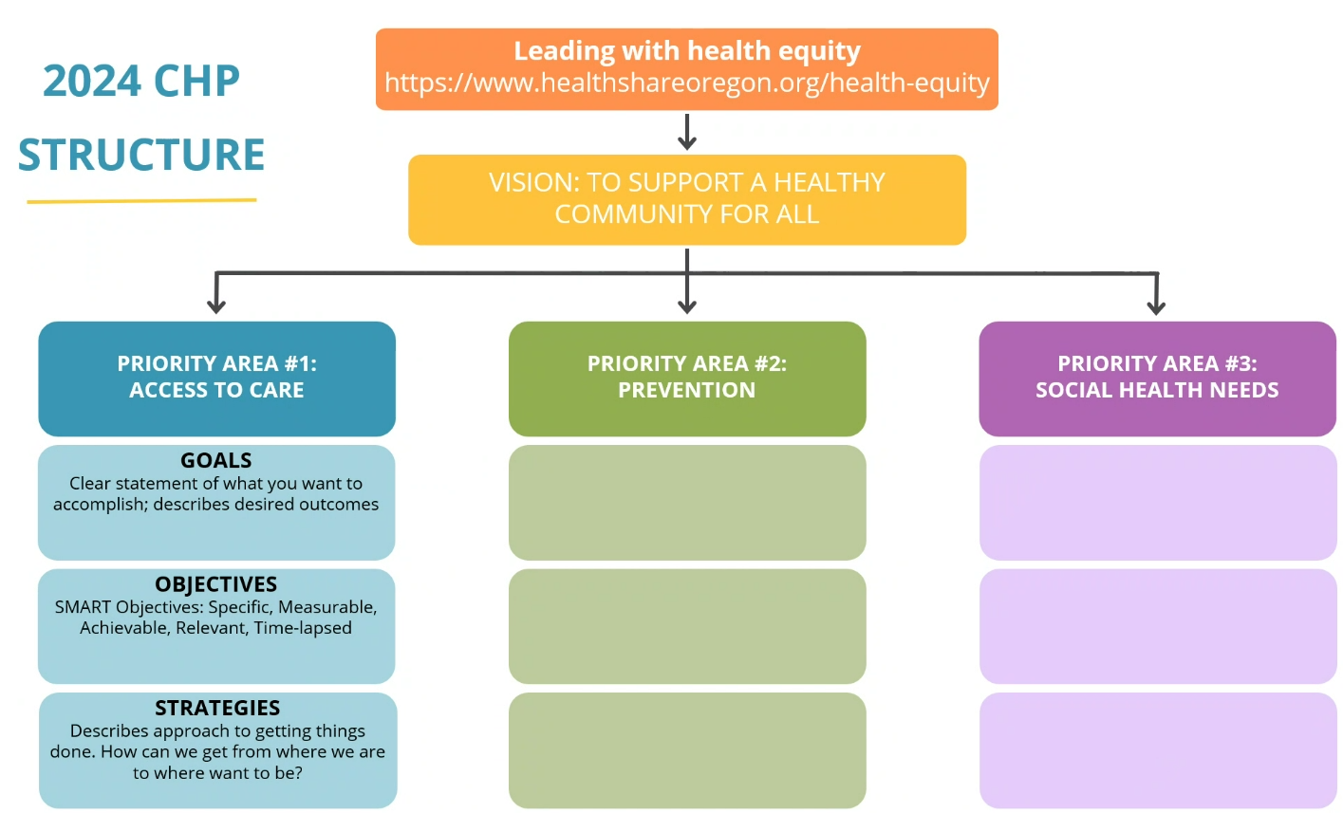

Share experience from the June 25 Community Health Event

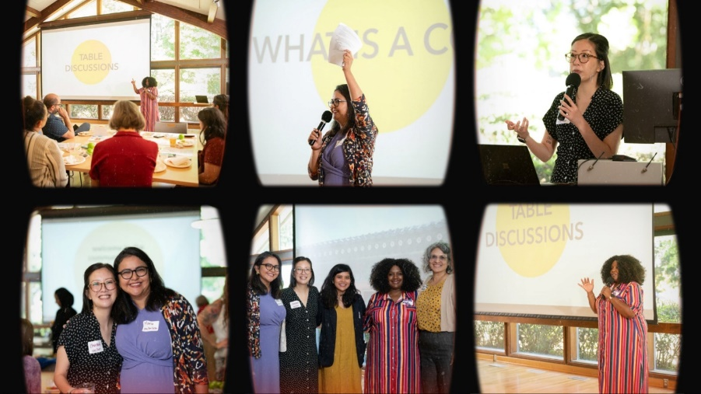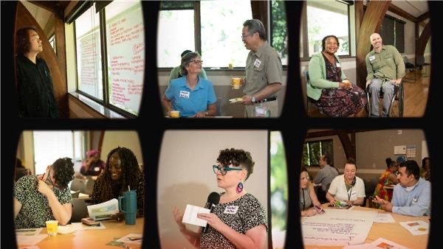

Asked the group to answer these questions

1. What do you expect from CCOs and what do you hope your CCO can accomplish in the next ~5?
2. As you consider Access to Care, Prevention and Social health Needs: What gaps/barriers are you aware of that your service population/community experiences?

Community Input Themes

* Language Access (Dialect + Education): more culturally/linguistically accessible services + resources.
* Make grant applications + process more accessible for the community.
* Need more education around how to navigate benefits and health system.
* Flex funds need to be more equitable.
* Increase networks for sharing information and resources.
* Daycare/childcare resources are fundamentally limited.
* Disaggregate Data.
* Behavioral Health: Remove stigma culturally sensitive way and provide more benefits education.
* SUD: Education on alternative drugs/weaning process; Provide Free Narcan.
* I desire more in-person meetings to learn about CCO work in community health.

Celia Harris – Contractor

* Partnering with Christine to provide support and additional capacity towards completion of Community Health Plan.
* Brings expertise in data analysis and storyboarding.
* Will help to analyze data and support strategy + narrative development, utilizing knowledge of existing/developing work at Health Share and desired outcomes for in the priority areas of CHP.

Option for CAC participation

The CHP has significant work and discussion that needs to happen. As this is a major project, we anticipate an additional, optional meeting that will take place in August. Christine asked if there was a group of CAC volunteers or if the entire group would want to participate in an optional August 2024 meeting to discuss the CHP solely. All hands went up. A new meeting will be polled by Christine. There might be an additional meeting in September, details to follow. The plan is to have a skeletal structure of the CHP by the end of the August meeting.

**Wrap-up**

Luci Longoria wrapped the meeting up by reminding the group that they can send in meeting topics and future agenda items if they come up.

Potential August agenda items include:

* CCBF recommendations
* SDOH Metric
* Traditional Health Worker workgroup

No additional questions or comments were made. Meeting adjourned.

**Meeting Schedule:**

Next meeting is scheduled for a **virtual meeting** on **August 14, 2024** from **1:30pm – 3:30pm**.

|  |  |  |
| --- | --- | --- |
| **Participation** | | |
| **Organization** | **Representative**  **(Indicate Proxy if present)** | **Present** |
| Oregon Health Authority | Mark Cokenour | x |
| Clackamas County Council Representative | Jaime Zentner | x |
| Multnomah County Council Representative | Natasha Davy | x |
| Washington County Council Representative | Magdalena Ramirez | x |
| Health Share of Oregon | Abraham Rodriguez Guillen | x |
| Health Share of Oregon | Christine Kan | x |
| Health Share of Oregon | Christine Bernsten | x |
| Health Share of Oregon | Love Richardson |  |
| Health Share of Oregon | Luci Longoria | x |
| Health Share of Oregon | Maria Tafolla |  |
| Health Share of Oregon | Mariam Ukbazghi | x |
| Health Share of Oregon | Mariotta Gary-Smith |  |
| Health Share of Oregon | Marissa Sliwka *(recorder)* | x |
| Health Share of Oregon | Ophelia Vidal | x |
| Health Share of Oregon | Phyusin Myint | x |
| Community Council Members | Candice Jimenez | x |
| Community Council Members | Lung Wah Lazum | x |
| Community Council Members | Yamungu Seraya | x |
| Consumer Council Members | Francisco Elias | x |
| Consumer Council Members | Hilary Flaming | x |
| Consumer Council Members | Joy Mutare | x |
| Consumer Council Members | Lauren Riddle | x |
| Consumer Council Members | Rachel Schutz | x |
| Siletz Tribal Representative | Forrest Pearson | x |