|  |  |
| --- | --- |
| **Meeting Recap** | **April 10, 2024** |

**Welcome & Introductions**

Today’s meeting is a joint meeting with the Community Impact Member Advisory Committee (CI MAC). Luci Longoria welcomed the group and reviewed the agenda. She then started a round robin of introductions.

**Topic 1: SHARE Funding Discussion with CI-MAC**

The SHARE Initiative comes from a legislative requirement for coordinated care organizations (CCOs) to invest some of their profits back into their communities. After meeting minimum financial standards, CCOs must spend a portion of their net income or reserves on services to address health inequities and the social determinants of health and equity (SDOH-E).

The primary goals of the SHARE Initiative are to

Safeguard public dollars by requiring that a portion of CCO’s profits are reinvested in their communities; and improve CCO member and community health by requiring reinvestments go toward upstream nonhealthcare factors that impact health (for example, housing, food, transportation, educational attainment or civic engagement).

SHARE Process

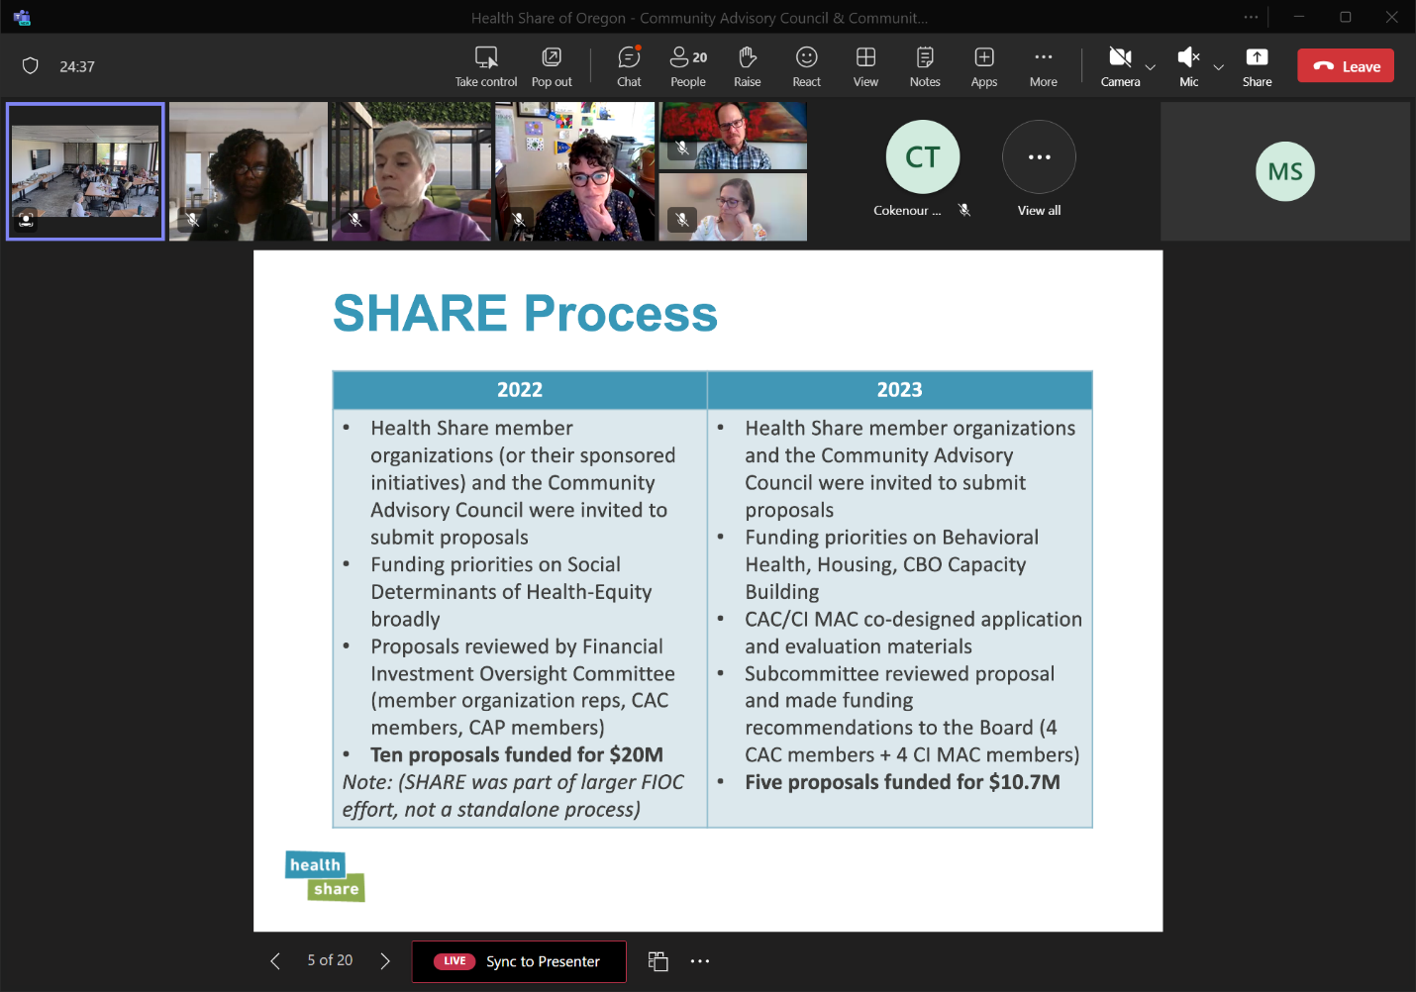

2022 SHARE Spending Plan

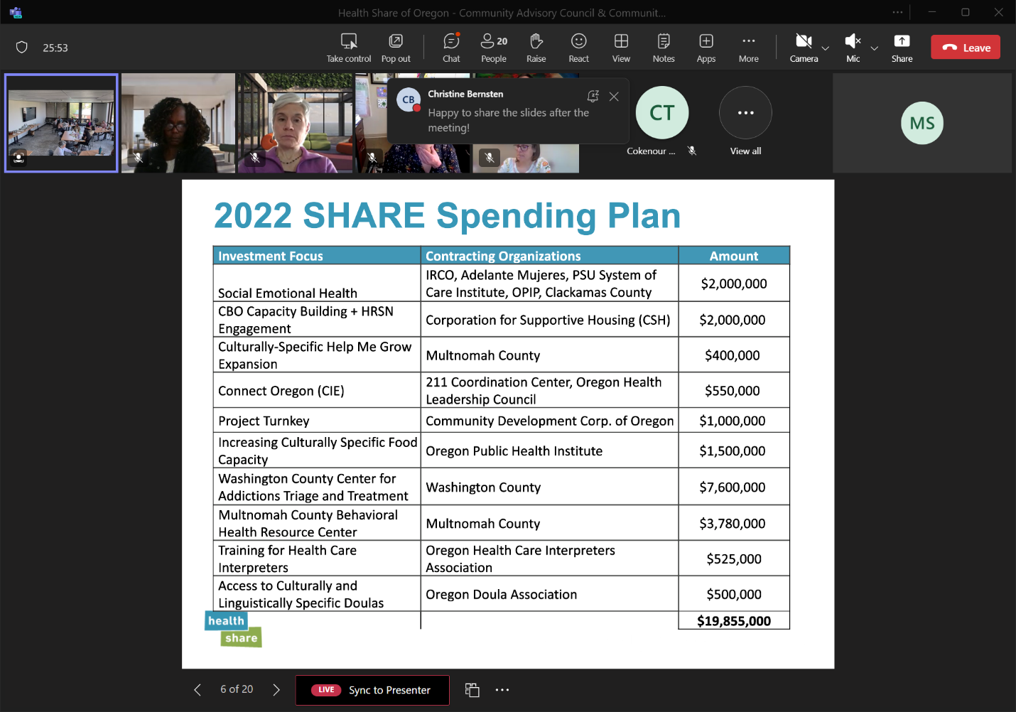

Constraints

* Less SHARE dollars are available to distribute this year.
* One-time funding.
* The capacity of Health Share staff to support several new investments.
  + 15 SHARE projects currently in process which consists of 22 contracts.
  + Community Capacity Building Funds – review applications, select organizations to fund, develop contracts, support implementation and it is unclear the number contracts will come for this.

Strategy Investment Options

* Option 1: Review current investments and determine if any projects need additional funding support.
* Option 2: Identify new investments to support; only capital investments, alignment with ecosystem priorities.
* Option 3: Braid SHARE funding to support things that cannot be paid for with CCBF dollars.
* Other 4: Other

Discussion

There was a robust conversation regarding the funding. There was a discussion regarding the administrative burden. The group then discussed the stop gaps and/or yearly. It was explained that this is more about being an OHA guidance which is more complex. If our members are getting their services, then we would have less SHARE money. One of the members stated that they were okay with option 1 & 2; although asked if the options could be adapted to what is needed. Another member asked if there was any idea of how much the SHARE funding will be for 2024. There was another question that came up about whether Option 2 would require a separate call for proposals.

Lastly a comment was made about one of the takeaways from the previous SHARE experience. We want to ensure that with this next round that we had time to be more deliberative in the process for identifying potential CBO applicants. The last process was limited to the CIC MAC members identifying possible applicants. Additional feedback given was:

* This is one-time funding; it is not intended to support programs or services for the long run.
* $2.8M is significantly less to distribute than there has been in the last two years.
* Recognition of limited staff capacity to support several new investments and grant recipients, or additional Request for Proposal processes as one is underway for distribution of the $10.8M in Community Capacity Building Funds to support readiness for delivery of the new Health Related Social Needs benefits, and a latter one for implementation anticipated.

Overall, the CAC and CI MAC were most supportive of option 1 or 2, although there it was suggested if there was a way to combine them, that could be ideal. The group also expressed interested in hearing from the Board what their priorities for this funding are. Staff briefed the Board Community Impact Committee (CIC) on this discussion.

The plan was to determine a consensus strategy and approach for SHARE funding that will inform funding decision to be made at May CAC meeting. It was determined to give the team two weeks to provide feedback regarding the different options discussed.

**Topic 2: CHP and CHNA Goals and Next Steps**

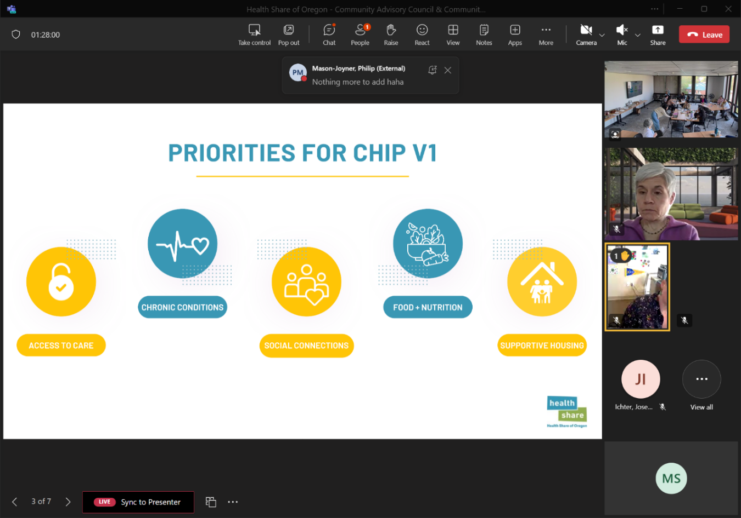

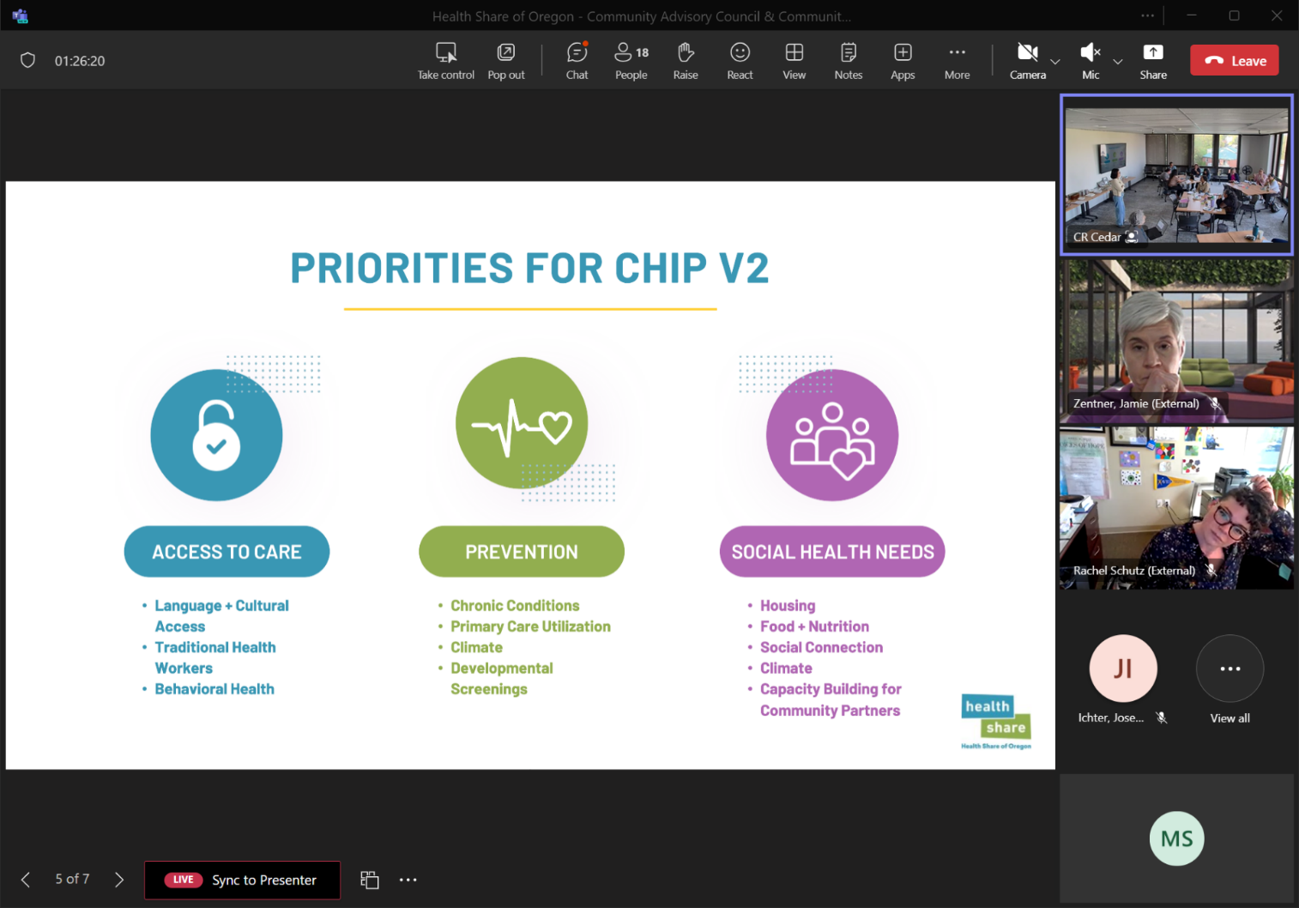

Discussion

The group discussed the Community Health Improvement Plan (CHP). It was communicated that the desired outcome is an approval on the “merged” priority areas that were discussed above for the Health Share’s CHP which will be submitted at the end of this calendar year. The team had a robust conversation, although a decision was not made. It was determined that the group would have some time to process what was discussed and a vote would be captured over email. The group will have by end of day Friday, 4/12 to provide an approval of the 3 priorities or to provide feedback. If there are no votes against or feedback recommending change to the 3 priority areas, then the plan will move forward.

**Topic 3: CAC Board Liaisons and Member Recruitments**

The group discussed the next steps for choosing Board liaison. We went over the two nominated members, Hilary Flaming (she/her) and Lauren Riddle (they/them), who are interested in serving as the Board Liaison for the CAC.

To give the group time to think about the choices and provide addition information if needed the vote will be captured through email. It was determined that all votes need to be submitted by Monday, 4/22. The hope is to announce the CAC Board Liaison nominee to the Board of Directors at the joint Board/CAC meeting on Wednesday, May 15.

**Wrap-up**

The team was asked if there was anything else they would like to discuss and nothing additional was brought-up. Meeting adjourned.

**Meeting Schedule**

Next meeting is scheduled for **May 8, 2024**, from **1:30pm – 3:00pm**.

The following meeting is a joint meeting with the Board scheduled for **May 15, 2024**, from **3:00pm – 5:00pm** at the Asian Health and Service Center.

|  |  |  |
| --- | --- | --- |
| **Participation** | | |
| **Organization** | **Representative**  **(Indicate Proxy if present)** | **Present** |
| Clackamas County Council Representative | Jaime Zentner | x |
| Community Council Members | Candice Jimenez | x |
| Community Council Members | Lung Wah Lazum | x |
| Community Council Members | Triniece Rozier-Sheidun | x |
| Community Council Members | Yamungu Seraya |  |
| Consumer Council Members | Francisco Elias | x |
| Consumer Council Members | Hilary Flaming | x |
| Consumer Council Members | Joy Mutare | x |
| Consumer Council Members | Lauren Riddle | x |
| Consumer Council Members | Rachel Schutz | x |
| Health Share of Oregon | Anthony Montoya |  |
| Health Share of Oregon | Christine Kan | x |
| Health Share of Oregon | Love Richardson | x |
| Health Share of Oregon | Luci Longoria | x |
| Health Share of Oregon | Maria Tafolla | x |
| Health Share of Oregon | Mariam Ukbazghi | x |
| Health Share of Oregon | Mariotta Gary-Smith |  |
| Health Share of Oregon | Marissa Sliwka, *recorder* | x |
| Health Share of Oregon | Phyusin Myint | x |
| Multnomah County Council Representative | Natasha Davy | x |
| Oregon Health Authority | Rebecca Donnell | x |
| Washington County Council Representative | Magdalena Ramirez | x |

|  |  |  |
| --- | --- | --- |
| **CI MAC Participants** | | |
| **Organization** | **Representative**  **(Indicate Proxy if present)** | **Present** |
| Adventist | Vacant |  |
| CareOregon, Inc. | Jeremiah Rigsby |  |
| Central City Concern | Vacant |  |
| Clackamas County | Philip Mason-Joyner | x |
| Health Share of Oregon | Alyssa Craigie |  |
| Health Share of Oregon | Christine Bernsten | x |
| Health Share of Oregon | Christine Kan | x |
| Health Share of Oregon | Katie Unger |  |
| Health Share of Oregon | Love Richardson | x |
| Health Share of Oregon | Maria Tafolla | x |
| Health Share of Oregon | Mariam Ukbazghi | x |
| Health Share of Oregon | Marissa Sliwka, *recorder* | x |
| Health Share of Oregon | Maureen Seferovich |  |
| Health Share of Oregon | Peg King | x |
| Health Share of Oregon | Phyusin Myint | x |
| Hillsboro Medical Center | Vacant |  |
| Kaiser Permanente | Catherine Potter *attended for Tracy* | x |
| Kaiser Permanente | Tracy Dannen-Grace |  |
| Legacy Health | Kamesha Robinson | x |
| Multnomah County | Alexis Ball | x |
| OHSU | Maggie Klein | x |
| Providence | Joe Ichter | x |
| Washington County | Erin Jolly *attends for Genevieve* | x |
| Washington County | Genevieve Ellis |  |