Meeting Recap | June 12, 2024

Welcome & Introductions
Luci Longoria welcomed the group and reviewed the agenda. She then started a round robin of introductions.

Topic 1: Update - CCBF
Maria Tafolla presented updates on the Community Capacity Building Funding (CCBF). Maria started off the presentation with an appreciation to both Ophelia and Jamie for their working and support in this process.

Community Capacity Building Funding (CCBF)
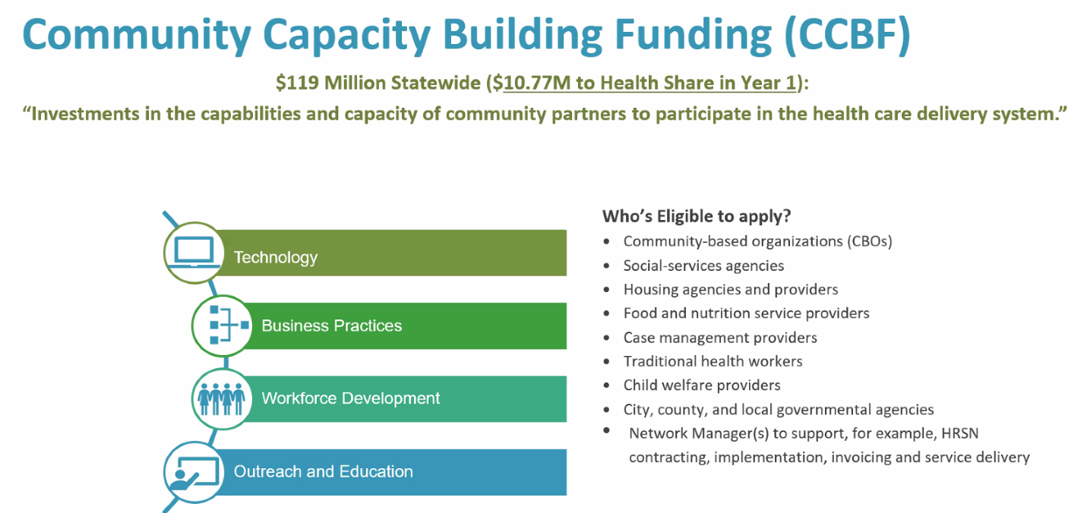

Funding Background and 2024 Goals
- Health Share has received 10.77M to award for 2024.
- This funding must support the development of a provider network for HRSN housing and food benefits.
- Health Share developed and publicly shared funding priorities for 2024 and stated investments would be made in specific categories.
- Application closed Friday, May 31st.
- Funding recommendations are due to OHA Monday, June 17th.

CCBF Application Statistics
- 99 applications were received. Out of the 99 applications -
  - 64 organizations asked for funding to support Housing Benefits.
  - 60 organizations asked for funding to support Food Benefits.
  - 10 organizations asked for funding to perform Network Hub functions.
- There was a requested total of $51,370,843.
- The review panels met this week; coordinating with Trillium and Yamhill CCOs on overlapping requests.
- Requesting approval of funding recommendations from Health Share’s Board Executive Committee on Thursday, June 13th

Maria expressed that we received a lot of feedback regarding the process and will be taking it back to OHA. It was also noted that there was alignment in decision making process. We will be going to the Executive Board Leadership.

Funding Recommendation Decision Making Process
- Health Share reviewed applications for eligibility and other “must meet” criteria before disbursing them to the review panel members.
- Panels weighed application scoring, budget reasonableness and provider readiness to make recommendations for funding.
- Health Share is meeting with Trillium and Yamhill today to discuss/align on recommended funding amounts for organizations with overlapping funding requests.
- Health Share will supplement the CCBF allocation with an additional $.3M from 2024 SHARE and an existing contract for HRSN Capacity Building with CSH

Draft Funding Recommendations
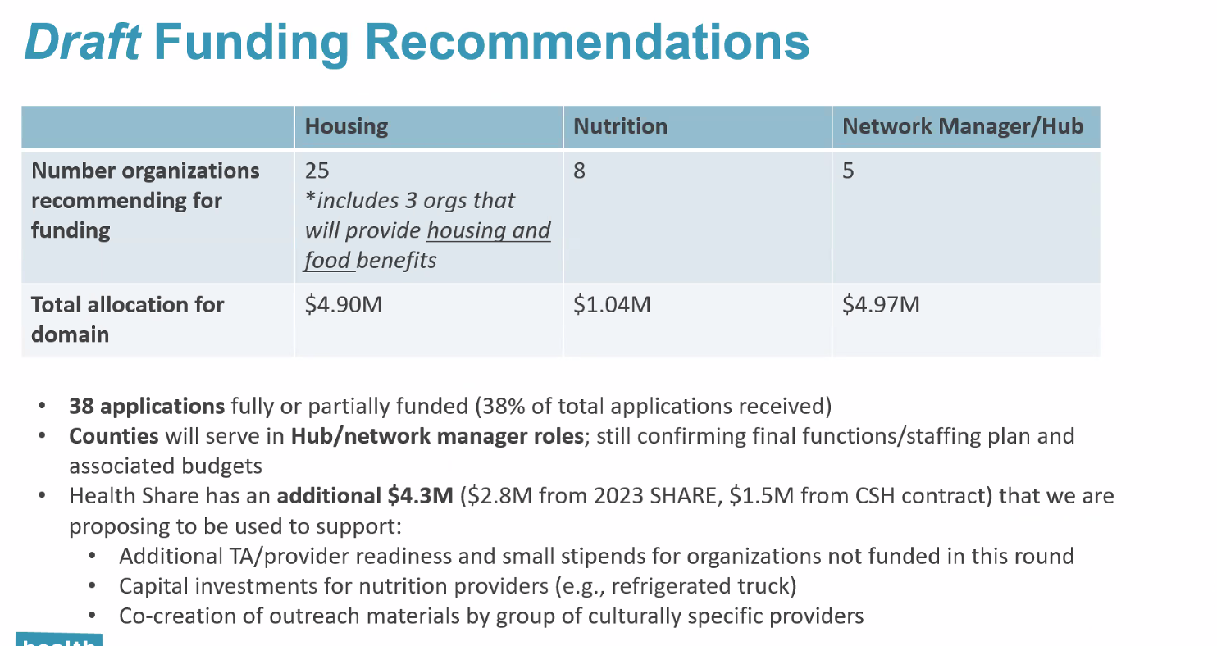

Discussion
The team was asked if there were any questions or feedback and the initial comment was a congratulations to the team. There was a question about Housing as they thought it was 2M. It was stated that additional money was able to be reallocated to Housing. The priorities for CCBF for 2025 will most likely be different. There were discussions about feedback that came out of these meetings as well as collaborative conversations.

Topic 2: Community Engagement Operation
The team was informed of the following community engagement operations:
- The CAC-appointed Board Liaison, Hilary will be interviewed and is continuing through the process. Candice asked if she is able to vote when it goes to the board and it was stated that she will need to follow up on this with the board.
- CAC membership and recruitment updates where given. Luci is working with Maria regarding the general membership of the other candidates who applied. They are taking time to assess the group dynamics as they review candidates.
  - The team was informed that Luci received word from Triniece that she is stepping down from the CAC, so there will be an additional application to come through.
  - Luci and Love will be discussing how to advocate for a Grande Ronde liaison.
- CAC Stipend Process – Don’t forget this is available.
- We will be welcoming a new Community Engagement Staff, Abraham from Benton County Health.
- There are two surveys in the works:
  - The Health Share Governance survey is due July 5 – Karla Tupper sent it out in an email.
  - There is also a survey to gather data needed for OHA Demographic Report due June 19. This will be collecting demographic regarding you for the CAC. Robust conversation regarding this topic.
- The team was invited to the OHA Quality Incentive interview to discuss the information that OHA wants from the community advisory members.

Topic 3: 2025 Legislation Framework
Anthony Montoya present information on the policy issues we are focusing on for our 2025 legislative work. When these issues come up, we are able to have ability to look at the bill and see if we are aligned with it.

What is the Legislative Framework?
- Guides our Public Policy during the 2025 Legislative Session.
- Aligns Health Share collaborative around common issues.
- Helps evaluate legislation but does not force Health Share to endorse or oppose any specific bill.
- Developed by GA Workgroup and reviewed by CAC, approved by CI MAC, CIC and the Board.

2025 DRAFT Legislation Framework Contents
Guiding Principles – Promoting Health Equity
Policy Priorities
- Sustaining Access to Member Services
- CCO 3.0 Reprocurement
- Behavioral Health
- Early Life Health
- Social Determinants of Health

Anthony stated that Health Equity is essential to all this work.

Governance Process in Brief
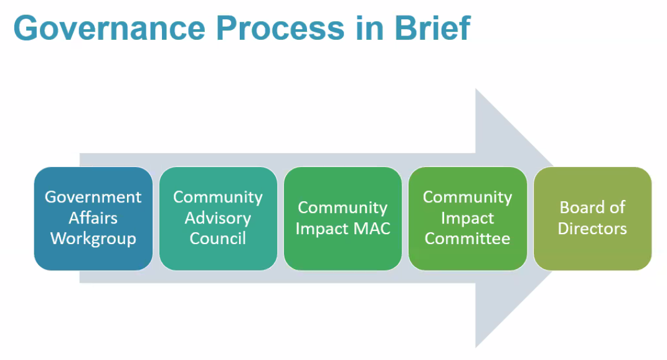
Promoting Health Equity
Support policies promoting Health Equity through alignment with Health Share’s strategic and health equity plans. Health Share leads with race – acknowledging the vast and ingrained structural barriers that produce inequitable health outcomes. Health Share is dedicated both in the short term in this legislative session and in our current strategic plan through 2024 to directly address the root causes of health inequities.

Health Share of Oregon acknowledges the inequitable health outcomes and the deep and lasting impacts of structural and pervasive racism on marginalized populations, particularly for communities of color. We seek to recognize, reconcile and rectify historical and contemporary injustices as part of our continual learning and action. Health is committed to eliminating health disparities for our members of color, those most harmed by systemic and structural oppression, and all of the communities we serve.

Promoting health equity is not a singular goal, but a through-line in all of work across the Health Share collaborative, and a critical lens through which we evaluate Health Share’s strategic priorities.

Guiding Questions – Health Equity
- What elements of health equity are under-considered by policy makers? What can Health Share do to focus attention on these areas?
- How can Health Equity be better represented across our policy priorities?
- Who else should be included in conversation about setting policy priorities?

Discussion
It was stated to think about the people who participate in the process. Who has the time and resources to do it. It is the white people. It’s missing the community of color. The question is how do we get them there.

Social Determinants of Health
Health Share continues advocate for equitable policy solutions that address profound differences in health outcomes perpetuated by social determinants. Support policies consistent with waiver implementation, including the nutrition, climate, and housing benefits that support health equity and leverage other regional assets and relationships. Special attention to policies that integrate existing resources and structures to address social determinants through CCOs and reimbursement structures that sustain benefits to address social determinants, especially by partnering and contracting through existing county infrastructure.

Guiding Questions – SDOH
- How can CCOs like Health Share continue to support people with their health challenges outside of a doctor’s office?
- What services in addition to what Health Share currently provides or will provide soon (transportation, housing, climate and cooling, nutrition support) would assist members in addressing social determinants?

Guiding Questions – Behavioral Health
- What is the ideal member experience in Behavioral Health, and how can we reflect that model into legislation?
- What is needed to move toward access, high-quality, trauma-informed, culturally responsive, and holistic behavioral health services? What do you feel is missing from this conversation?
- The ways our behavioral health systems behave, act, respond and change.

Future Engagement and Continual Feedback
- Health Share’s Legislative Framework is only one product of many that are within the scope of our policy work.
- It is likely that this framework will continue through the Governance process with final approval later this month.
- Before that time, please reach out to Anthony or Luci with additional thoughts.

Discussion
Anthony would like to come back more often during the 2025 legislation period to give updates and gather feedback. This is a living and breathing document until the Board approves it. The group was asked if there were any comments or feedback.
- A comment was made about elevating the need for more providers that can provide culturally and linguistically appropriate services. Maybe a call out to support this across (behavioral health and SDOH); outside of interpretation and translation – have providers that are representative of the members needing the care and services.
- A question was asked of Anthony: Are there any items in 2025 that you are aware of, that we should be aware of from legislators as far as their priorities or certain bills in the works, for example. Anthony reviewed many of the different pieces of legislation we will be watching closely.
It was asked if the group would like to have Anthony return to have further discussion on this topic as there is not enough time to discuss it in-depth further.

Topic 4: Updates on CHIP
There was a quick announcement to save the date on June 25th for the Community CHP event.

Wrap-up
The team was asked if there was anything else they would like to discuss and nothing additional was brought-up. Meeting adjourned.

Meeting Schedule:
Next meeting is scheduled for July 10, 2024, from 1:30pm – 3:00pm.

Participation
Organization | Representative  (Indicate Proxy if present) | Present
Clackamas County Council Representative | Jaime Zentner | x
Community Council Members | Candice Jimenez | x
Community Council Members | Lung Wah Lazum | x
Community Council Members | Yamungu Seraya
Consumer Council Members | Francisco Elias | x
Consumer Council Members | Hilary Flaming | x
Consumer Council Members | Joy Mutare
Consumer Council Members | Lauren Riddle | x
Consumer Council Members | Rachel Schutz | x
Health Share of Oregon | Anthony Montoya | x
Health Share of Oregon | Christine Kan
Health Share of Oregon | Love Richardson | x
Health Share of Oregon | Luci Longoria | x
Health Share of Oregon | Maria Tafolla | x
Health Share of Oregon | Mariam Ukbazghi | x
Health Share of Oregon | Mariotta Gary-Smith
Health Share of Oregon | Marissa Sliwka, recorder | x
Health Share of Oregon | Ophelia Vidal | x
Health Share of Oregon | Phyusin Myint | x
Multnomah County Council Representative | Natasha Davy
Oregon Health Authority | Mark Cokenour | x
Siletz Tribal Representative | Forrest Pearson | x
Washington County Council Representative | Magdalena Ramirez | x

